# Routing:

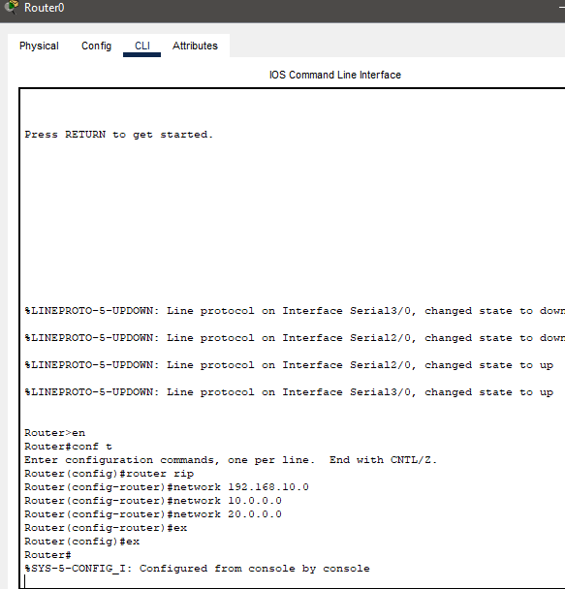

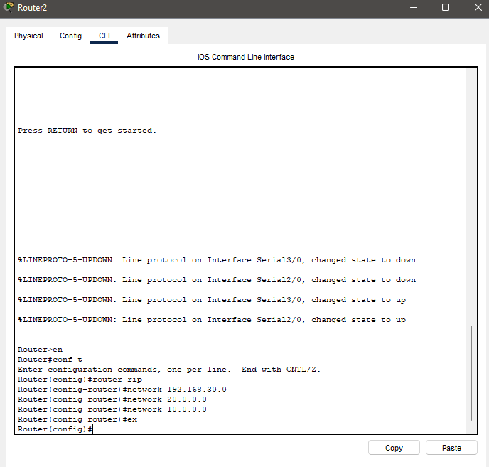

# Server IP’s:

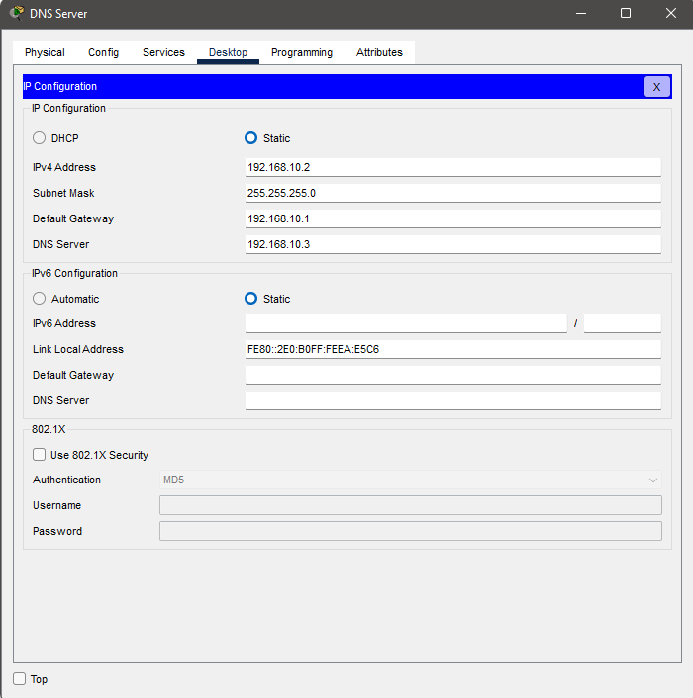

## DNS:

# VOIP Configuration:

